Website Deployment on AWS
Step-by-Step Guide Using Amazon S3
Cloud Computing | BSC-AI
AMAN PAL

Step 1: Open Amazon S3 and Create a Bucket
Log in to your AWS Management Console. Navigate to Amazon S3 from the Services menu or search bar. On the S3 homepage, click the "Create bucket" button on the right side of the screen to begin setting up your storage bucket.

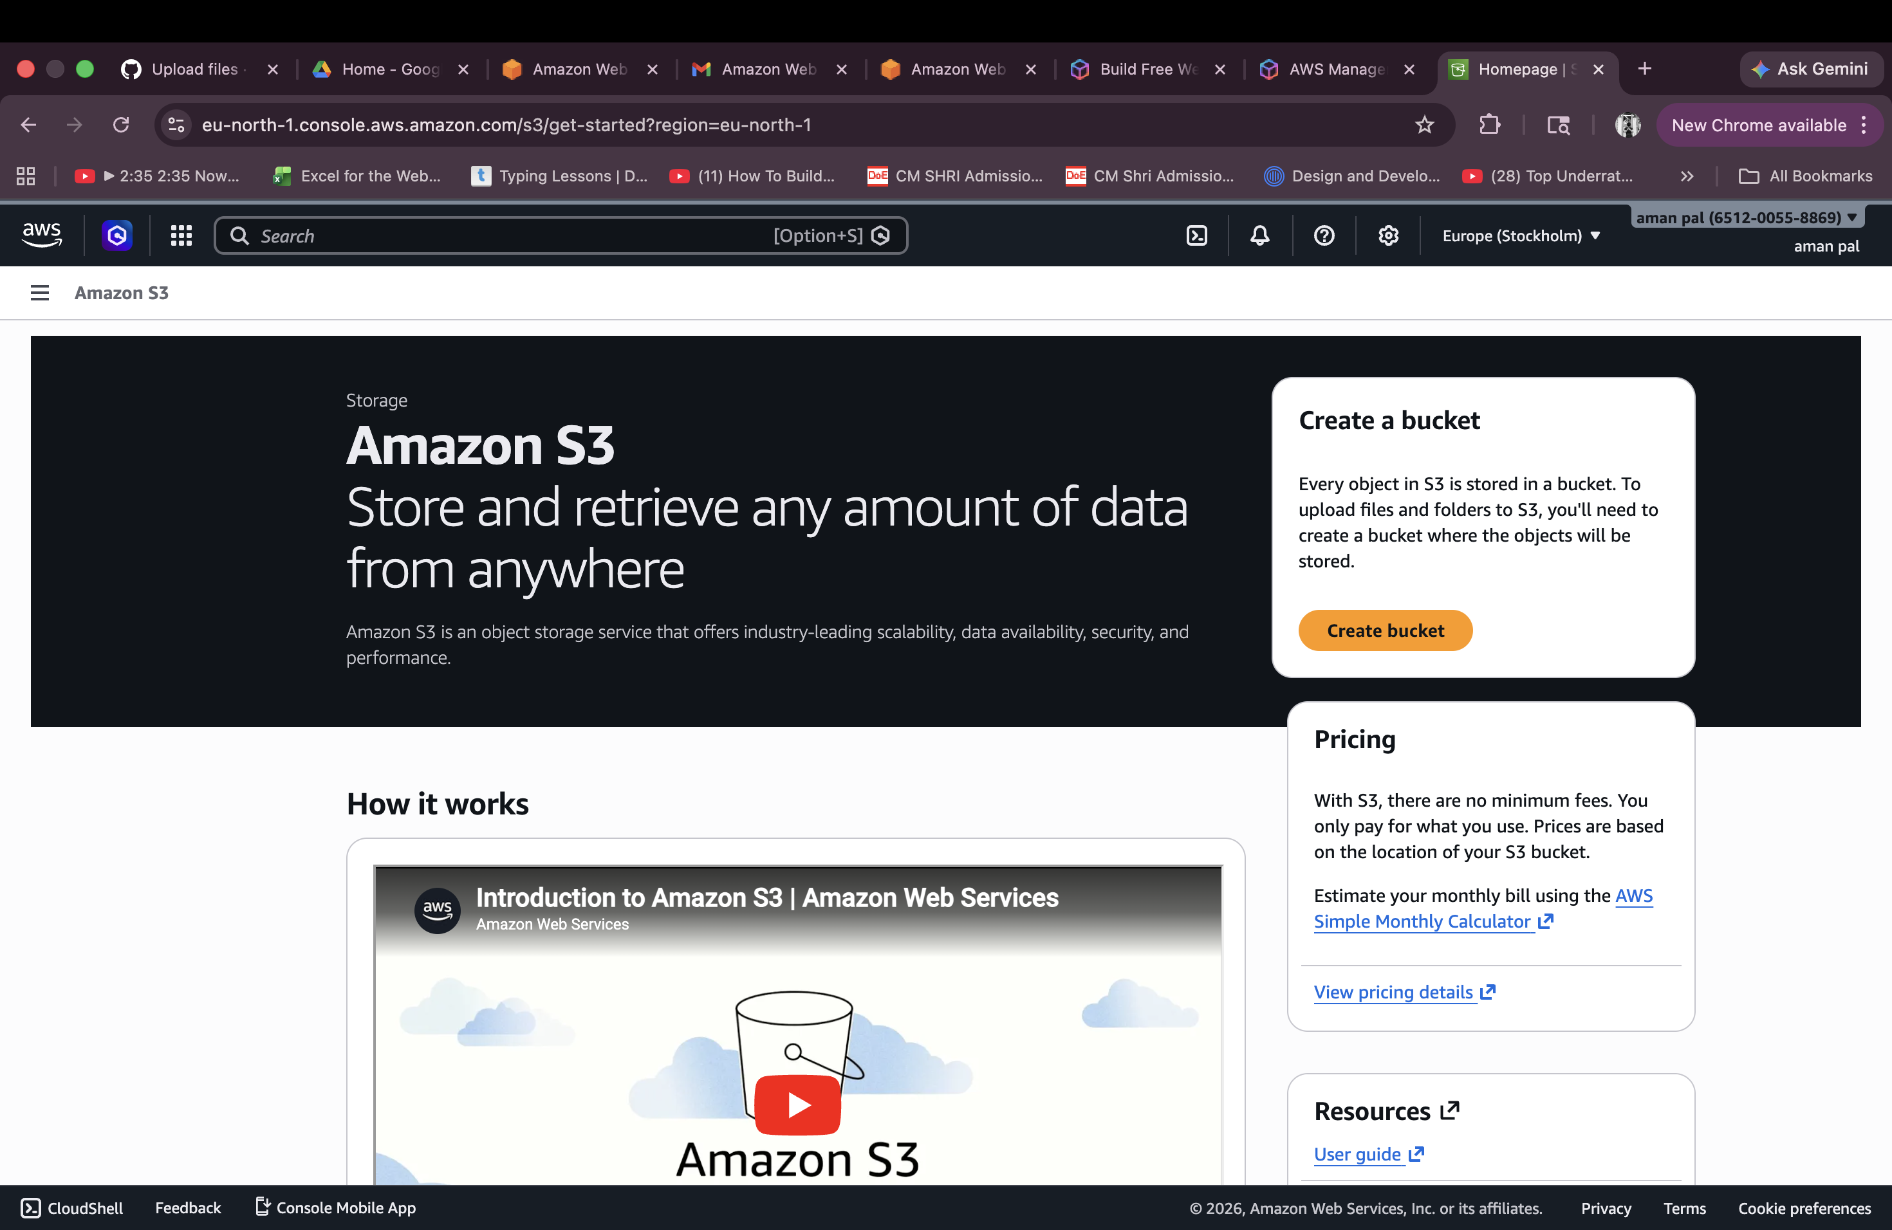

Step 2: Configure Object Ownership and Public Access Settings
In the bucket creation form, scroll down to "Object Ownership". Select "ACLs enabled" and choose "Object writer" under the ownership options. Then under "Block Public Access settings for this bucket", uncheck "Block all public access" to allow your website files to be publicly accessible. Acknowledge the warning that appears.
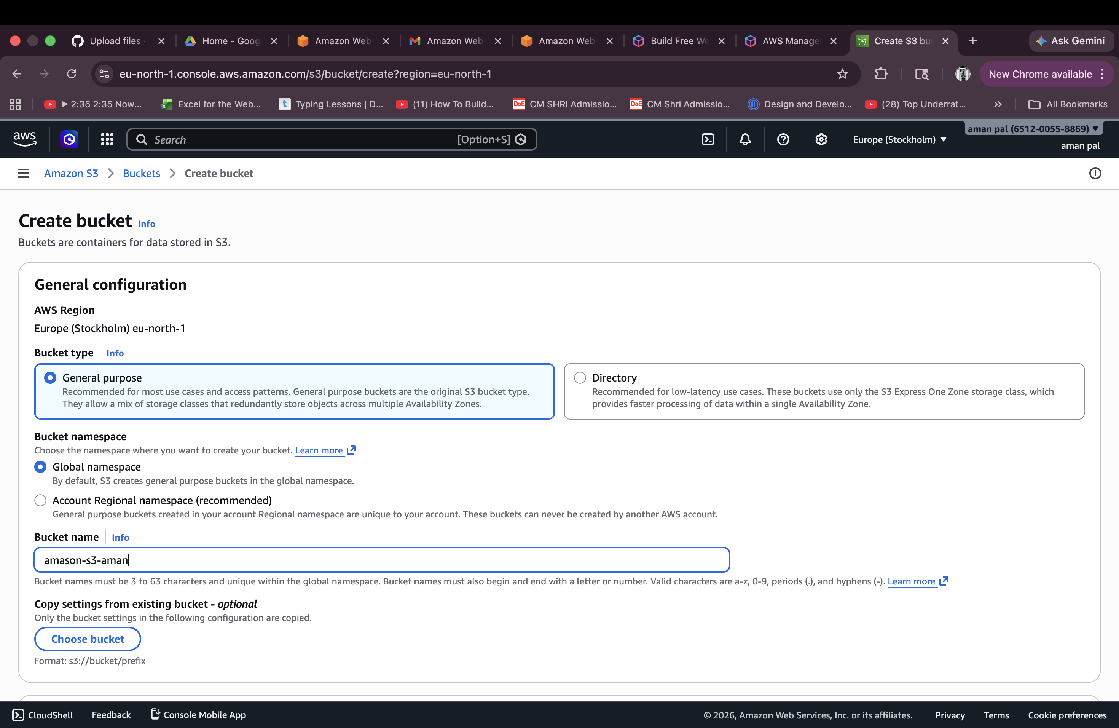

Step 3: Bucket Created Successfully
After configuring all settings and clicking "Create bucket", AWS will confirm the bucket has been successfully created. You will see a green success banner showing "Successfully created bucket 'iyushofff'". The bucket is now empty and ready for your project files to be uploaded.

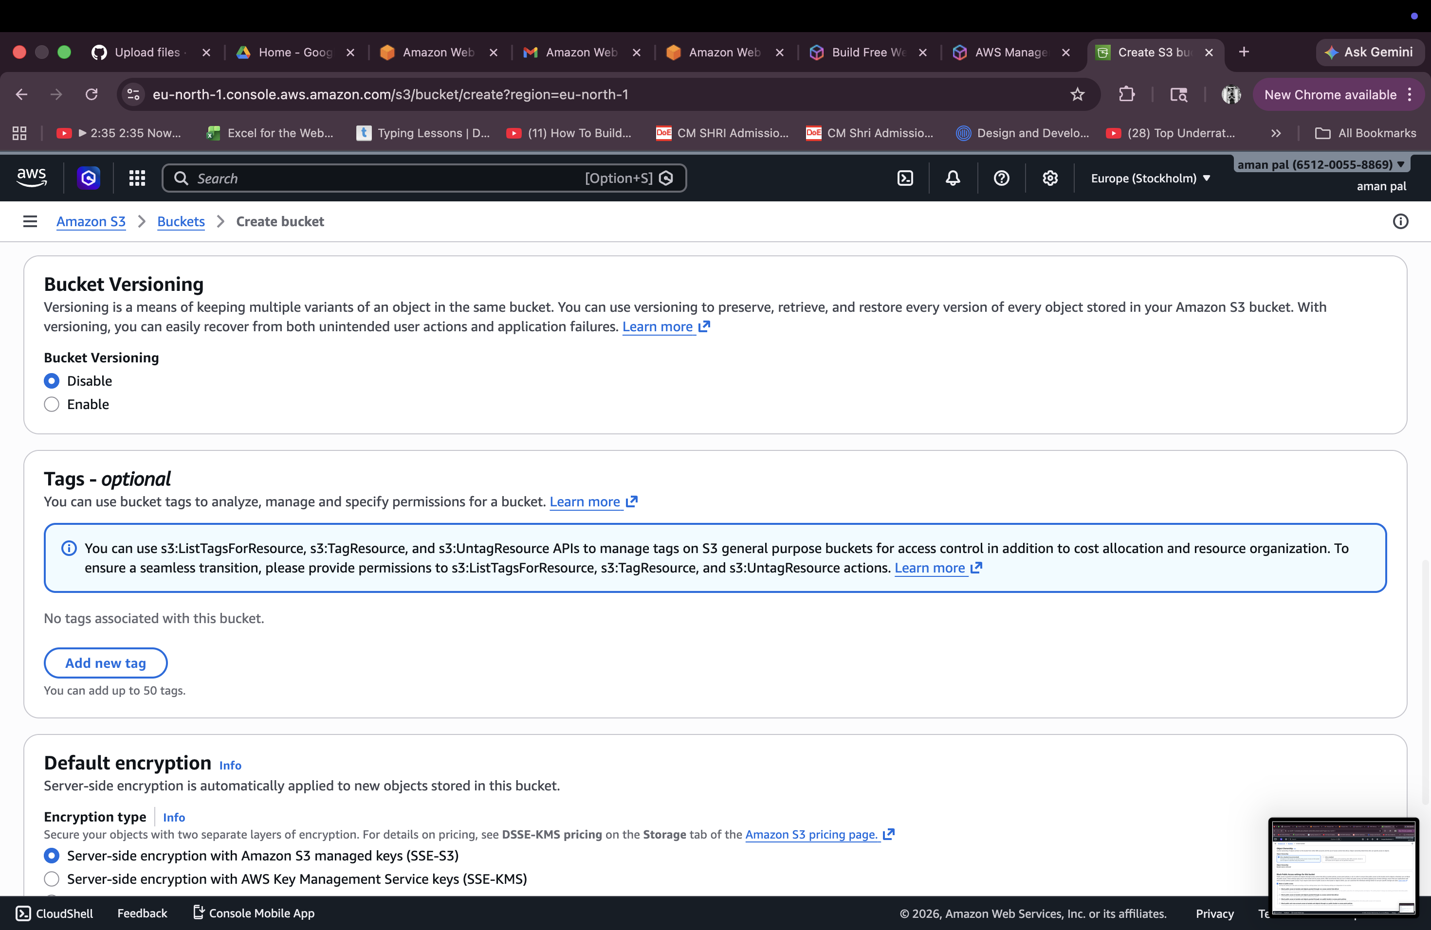

4: Upload Your Project Files
Inside your newly created bucket, click the "Upload" button. On the upload page, click "Add files" or "Add folder" to select your project files. Here, two files — test.html and test.css from the "test codes/" folder — have been selected for upload. The destination is confirmed as s3://iyushofff. Click "Upload" to proceed.
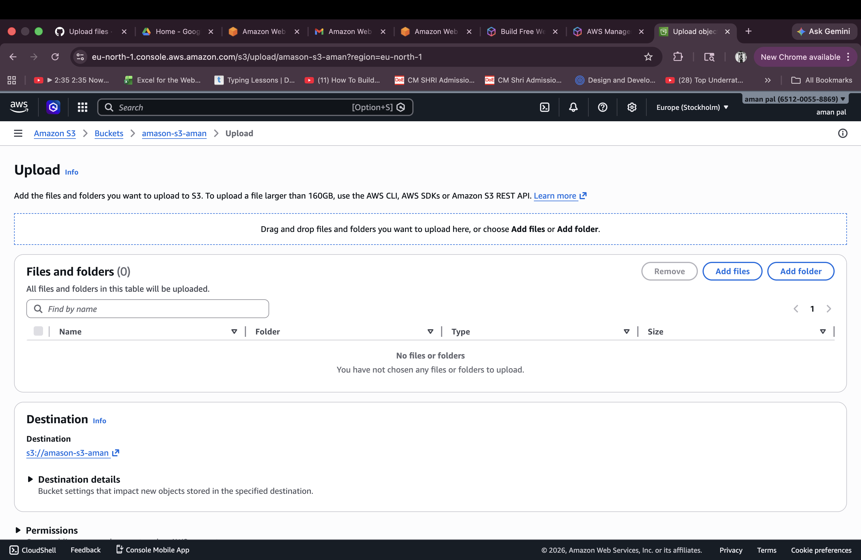

Step 5: Confirm Upload Success
After the upload completes, AWS displays the "Upload: status" page. The green success banner confirms "Upload succeeded". The summary shows both files (test.html and test.css, totalling 4.7 KB) were uploaded to s3://iyushofff with a 100% success rate. Click "Close" to return to the bucket.
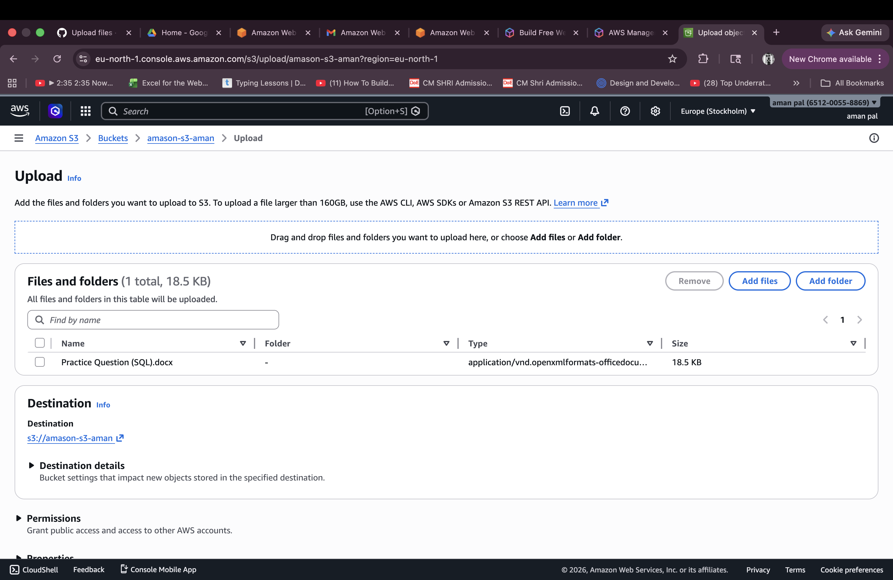

Step 6: Select Folder and Make Public Using ACL
Inside the bucket, select the checkbox next to the "test codes/" folder. Click the "Actions" dropdown at the top of the object list. From the dropdown menu, choose "Make public using ACL". This will open the confirmation screen shown in the previous step.

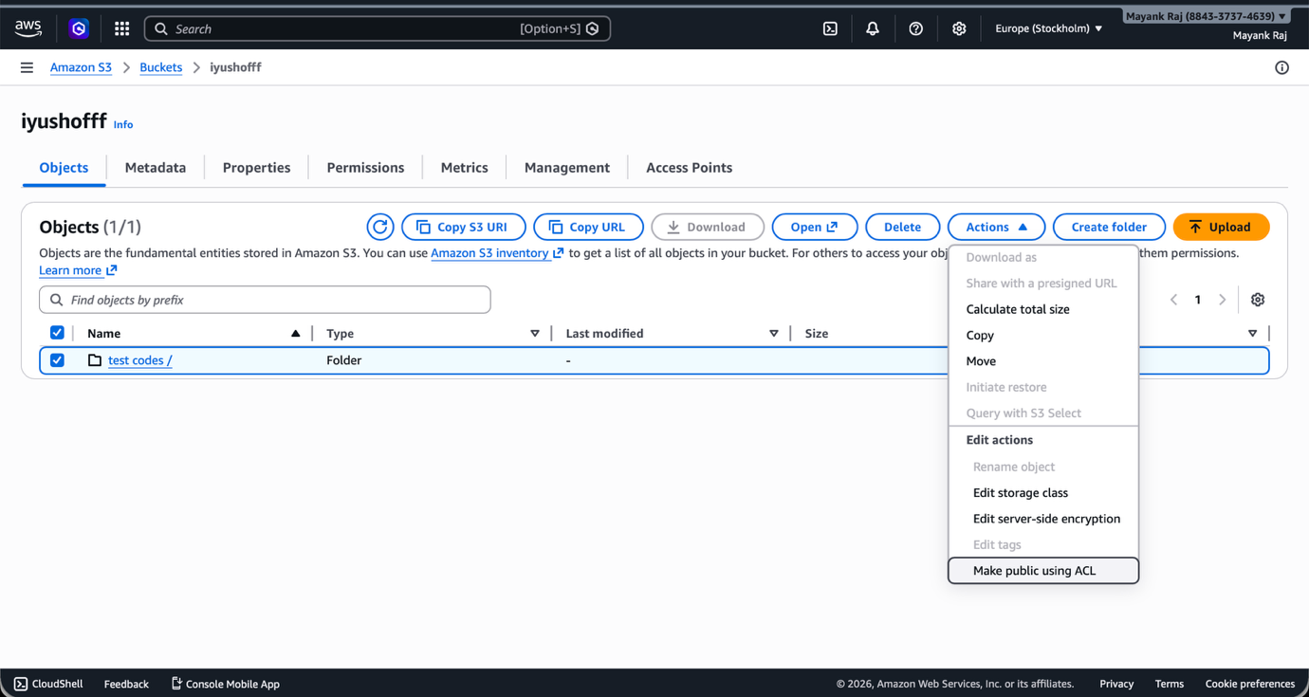
Step 7: Review the Make Public Confirmation Screen
AWS shows a confirmation page titled "Make public" before granting public read access. It lists the specified objects — in this case the "test codes/" folder — that will be made public. A warning is shown reminding you that anyone on the internet will be able to access these objects. Click "Make public" to confirm.

Step 8: Public Access Successfully Granted
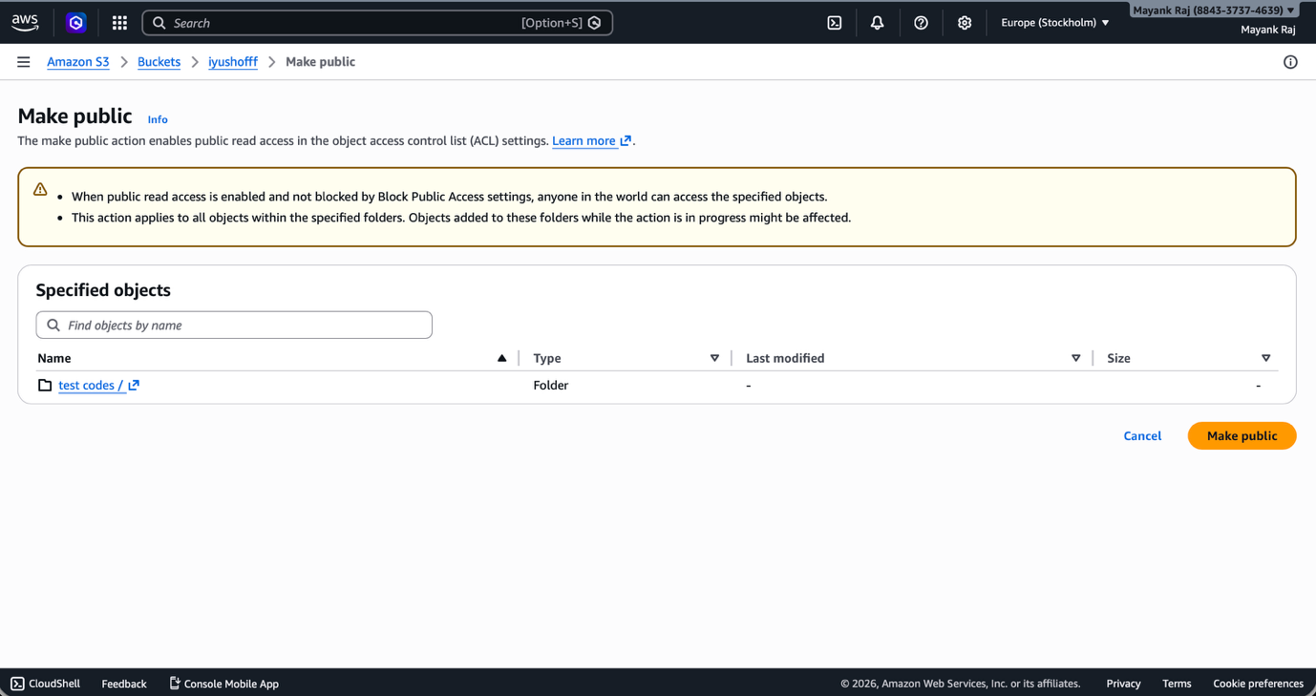
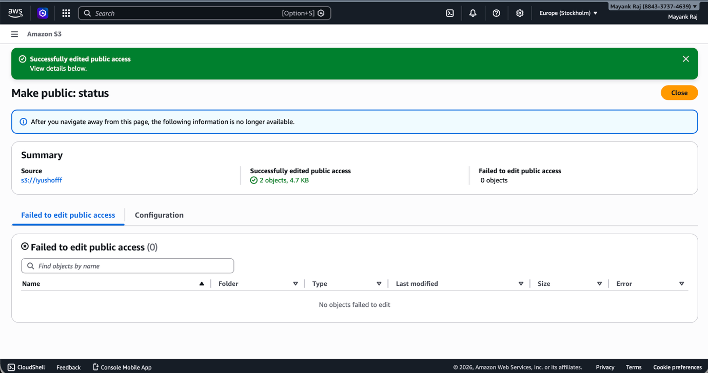
AWS displays the "Make public: status" page confirming the operation succeeded. The summary shows that public access was successfully edited for 2 objects (4.7 KB) from the source s3://iyushofff, with 0 failures. Your website files are now publicly accessible on the internet via their S3 object URLs.

